Dave Nuttall
ENG 2010 – 7:00pm
Memoir

Phoenix Unfound

It was a crisp, February morning in 2008 and I awoke to find the flight conditions very promising. With the rest of my family still sleeping and the first rays of sunlight streaming over the Wasatch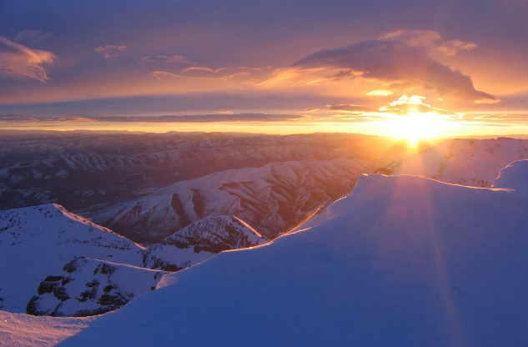Mountains, I tossed my paraglider into the back of my 1998 Pathfinder and quickly made the twenty minute journey across the Salt Lake Valley to the south slope of the Point of the Mountain near Draper, Utah.
Known the world over for its topography and predictable air currents, pilots like myself had been coming out to “the point” for years. The sheer excitement of soaring above the ridges, powered solely by one of the world’s few “inland ocean” wind patterns. This was made possible in large part by the topography of the point itself and its orientation in relation to both the Great Salt Lake to the north as well as Utah Lake to the south.
In my early years, I would travel through the area from my home in Montana to visit my grandparents and it was always a
trip highlight for me to look up and see the lone hang glider soaring back and forth
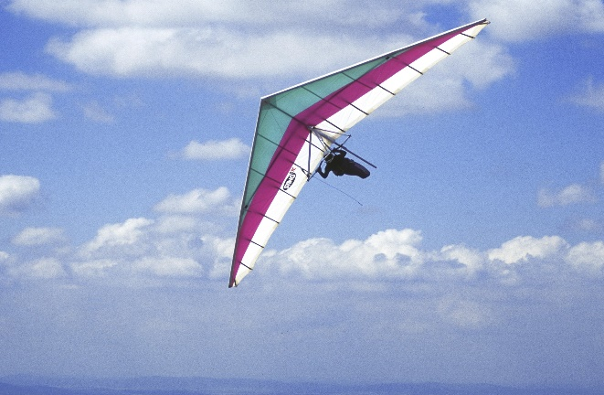
above the ridges, turning and spiraling so gracefully. I later moved to the Salt Lake Valley for college and began noticing what I initially believed to be skydivers out at the point. Inexplicably however, they were not jumping out of planes as I would expect but rather, they were launching and landing much the same way as the hang glider would do and my curiosity was piqued! In the months that followed, I would visit the point often just to watch them, vowing to myself that I would someday learn to fly that way too.
In April of 2007, I got that chance and began taking lessons with the raw exuberance of a kid at Christmas time! I was finally living a lifelong dream and it was great! Kevin Hintze was my instructor and I trained with him every chance I could throughout the spring and summer that year. 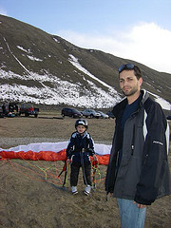Kevin, shown here teaching his son Adam to fly, is one of the best paragliding instructors out there and I loved learning from him! Many great mornings were spent on the south side. In the afternoons, if the winds were right and I could leave work a little early, I would go back for some north-side soaring as the sun went down, rounding out my version of the perfect day. By the time I completed my training and was officially passed off by my instructor, I felt like the world had opened up for me and that I could do anything. I, a mere human, had learned how to soar through the skies with the birds and it was amazing! Leonardo Da Vinci himself, had longed for this, was forever in 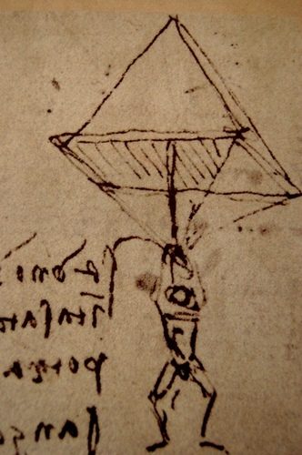pursuit of this very dream, and I was doing it! To attempt to describe the overwhelming joy I experienced each time I flew, to someone who has never experienced it or shared my passion for it, is akin to trying to explain those first golden moments when you are finally holding your brand new baby. Imagination is a powerful thing but actually experiencing things of this magnitude are simply life-affirming and I was eager for each new day!

That February morning, as I made my way around to the flight park on the south side, I could see that the recent snowfall had accumulated more heavily on the road and surrounding hillside than I had expected. As the road began to steepen and I started sliding a little, I shifted my truck into four-wheel drive, thinking this would be enough to get me to the top. About a third of the way up, the pavement gave way to an old dirt road which then winds along the shoulder, going the rest of the way up and around to the top. I could see from the tracks in the snow that others had not made it much further. I realized that if I was going to fly that day, I would have to hike and “earn” it. This was going to take some effort with all of my gear but I was no stranger to working for it and was very willing to put in the steps. I drove back down to the base, also known as the landing zone or LZ and parked with the others. After collecting my equipment and leaving any unneeded items behind in order to lighten my load, I began walking over to the base of the hill. As I walking away from my truck, I suddenly re-thought my decision to leave my cell phone behind and went back after it. Having left the house that morning with my wife still sleeping, I figured that I should keep my phone close to me just in case she tried to call me later. I quickly grabbed it out of my console, stuffed it into the pocket of my parka and started back up the hill again. I could see my breath in the chilly morning air as I made my way up the steep slope. By now, the sun was shining above the ridgeline just enough to help me really work up a sweat and the snow crunched and gave way beneath my feet as I walked. The elevation gain is only about 300 feet from the LZ up to the launch area and once I reached the top, I was ready to go enjoy the winds. Flying during the winter season is obviously colder, but with additional clothing and preparation as well as a stronger will to endure the elements, the flights can be spectacular. I, along with only a handful of other pilots, was more than willing to do whatever it took to catch a flight that morning. After a quick pre-flight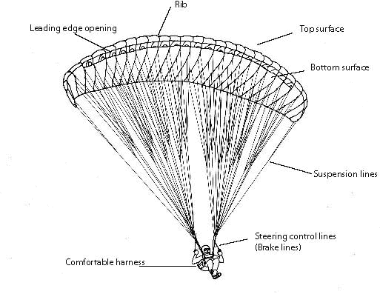check of my equipment including wing, risers and harness which is the pilot’s seating system, it was finally time to get up in the air. With a mild but steady breeze coming in from south, the launch was simple and I was airborne within a short time.
While gliding through the air, I was really enjoying myself and the relative calm was amazing that morning. The winds were not real strong but there was just enough lift to aid me along as I soared back and forth along the ridgeline. I snapped a couple pictures including the one shown here and 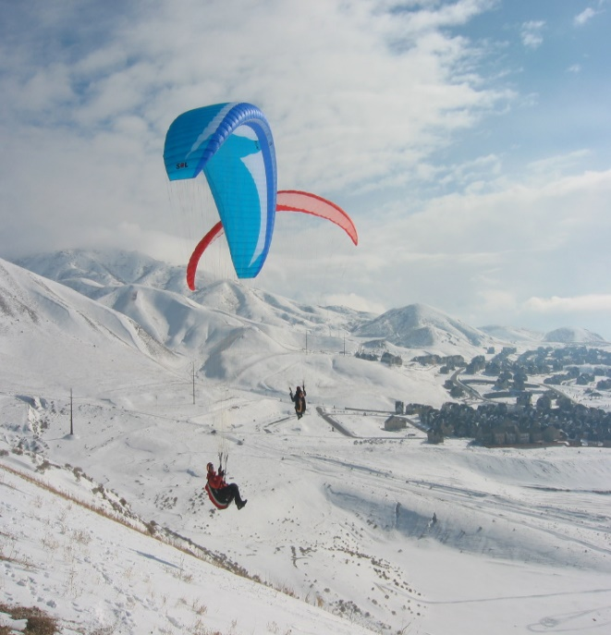then lazily soaked in my surroundings from above. I was king of the world at that moment and it felt so great! For the next thirty minutes or so, I flew the pattern, an elongated figure-eight routine used by the pilots in that area as a way of avoiding collisions while still making the best use of the winds.
On one pass, I noticed two pilots on the ground, preparing to take off. They were at the eastern end of the launch, an area which also happens to be the tightest section of the flight pattern. As I approached them, it looked as if they were about to launch regardless of my proximity to them. This was concerning to me because, as a general rule of pilot etiquette, wings on the ground are expected to give right of way to wings in the air. Fortunately, I was able to pass them safely but I knew that I was going to have to turn and pass them one more time in order to clear them completely. As I came around, both pilots proceeded to launch and I knew I would end up getting closer to them than I wanted, if I maintained my current course. In an effort to avoid them, I turned back to put in another pass. I suddenly saw, that while I had trained my attention on them, I had also given up more altitude than I realized. A split-second later, I slammed into a large sandstone slab formation laying partially buried on the crest of the hill. A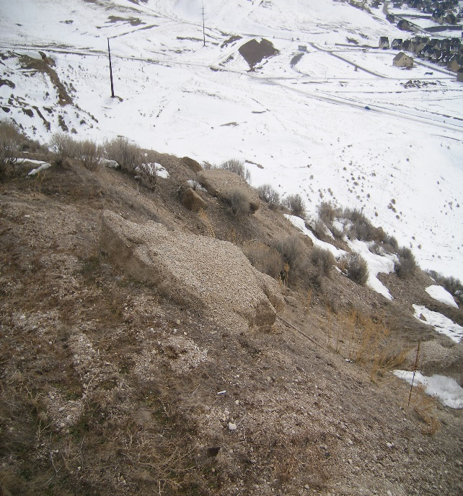couple of years before, most of the large boulders which were scattered across the hilltop had been pushed over the edge of the embankment in an effort to make the area safer. With stunning accuracy I had just found one of the only ones left! With the force from my initial impact shattering my femur and fracturing one vertebra in my lumbar spine, I was then propelled up and over the hilltop. The hill then dropped away very steeply for about forty feet at roughly the same angle that I was now falling. As I experienced with vivid clarity, the slow-motion phenomenon so often described by others from their own traumatic injury accidents, time became a twisted and bizarre irony for me. I was keenly aware of my body and the things that were happening to it as I was hurtling through the air, much like a ragdoll being thrown from a height. Knowing I was powerless to do anything to save myself, completely devoid of any semblance of control, I became a spectator of sorts, watching in grim anticipation as each new impact came into view. Although milliseconds seemed to click by at a painfully slow pace, in a peculiar contradiction, these same events also happened so fast that there was no time for fear, just a searing awareness that this would likely be the end for me. I remember having time to think about my kids and my wife and thinking that this just could not be the way it was supposed to end for me. My wife and I were expecting another baby girl in April and she would never get to know me. I would never get to hold her in my arms and kiss her sweet face and tiny fingers.
With another sickening thud, I was jolted back to the present as I collided with rocket-like speed into the second boulder at 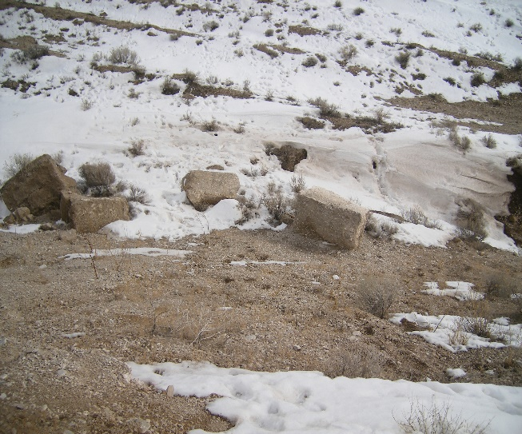the bottom of the embankment. It is believed that this impact was the moment when both my tibial plateau and fibula were broken. Like a dervish, I whirled up and over the large rock, still wondering how this could be real. The horrifying feeling I experienced as my body was repeatedly shattered and twisted, soft tissues ripping and tearing, was at the same time, a most surreal experience. I saw level ground coming at me very fast and then suddenly I was lying there, silently in the snow, still alive, as my glider began to descend to the ground behind me. I began to feel a sense of relief, that it was over and I might actually be okay, when I realized that the wind was still catching my wing. I knew that in my very broken condition, if a gust of wind were to catch it, I could be dragged and things may get even worse. I shook off the disorientation in my mind the best I could and worked to disconnect my wing from my harness. When the last connection was 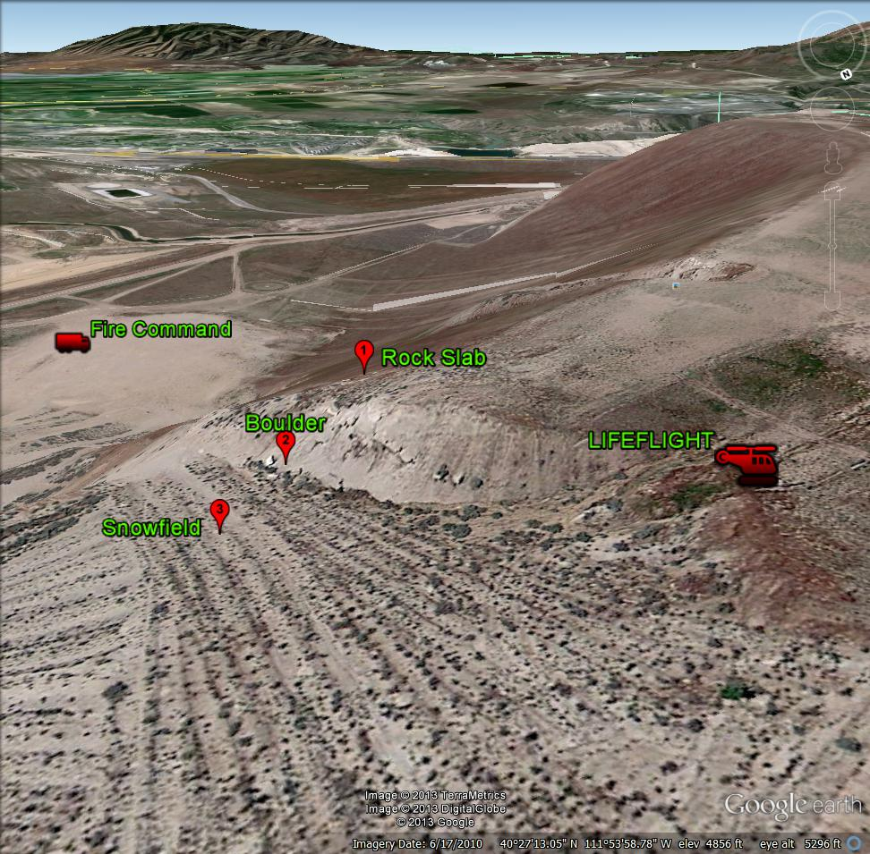.
finally released, I was able to breathe for a moment and assess my situation.
Laying in the snow, I was certain that my femur was badly broken and I also suspected a lower leg injury. The generalized pain throughout my entire body made it difficult to accurately determine how severe my injuries really were. The pain began to set in and it was becoming excruciating but I did my best to remain calm. After fourteen years as an emergency medical technician (EMT) and responding to trauma of all types, I knew that my problems were very serious and that there was no way I was getting out of there on my own. The outdoor temperatures were just above freezing as I lay there on the ground. I began yelling for help, hoping that someone would hear me and come to my rescue. Unfortunately, nobody answered, nobody came. I became terrifyingly aware that I could no longer see or hear anyone else. It was like everyone vanished. The area I had.
crashed into was at the far, east end of the park and anyone still flying that morning would be in the pattern, making their turns well before the embankment thus being unable to see me down over the edge. A feeling of despair hit me as I realized this and I started to wonder if my earlier belief that I would be okay was nothing more than misplaced optimism. While very aware of the need to hold still as much as possible, I tried to carefully shift my position enough to allow me a little more comfort. The pain was intensifying and I knew I needed to be cautious with any further movements. I remember thinking that it was going to feel so good as soon as the EMT’s arrived and placed a traction splint on my leg. This is when I remembered my cell phone and my decision to return to my truck for it. This buoyed my spirits again as I pulled it out of my pocket, dialed 911 and met my new best friend, Micah. We quickly covered the basic details and I settled in for what I hoped was going to be a rapid response. However, rapid was not in the cards that day. The deep snow hampered the response teams’ efforts considerably and the Life Flight crew lost valuable time after deciding to fly north into Davis County to install their rescue hoist which in the end, was actually never needed.
Micah was able to alert my wife and then kept me updated as I waited for help. After nearly an hour spent laying on the frozen ground, my friend, Dale Covington of Big Sky Paragliders suddenly crested the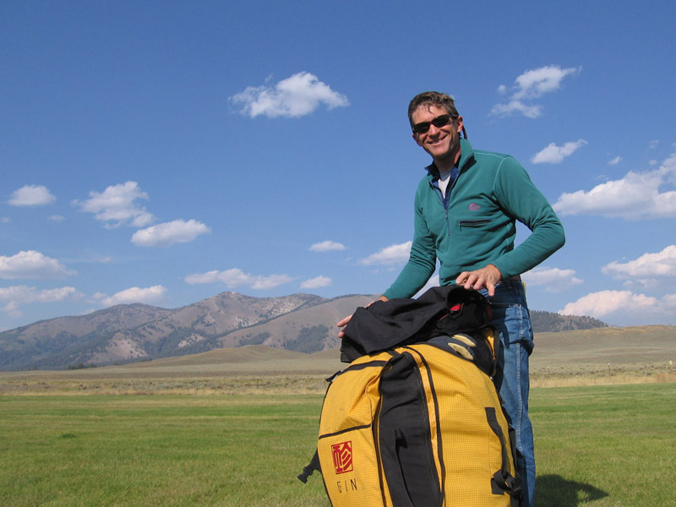hilltop above me yelling, “Here he is!” and was quickly followed by the first search and rescue crews. This moment was thrilling beyond description and the relief I suddenly felt was so profound! I was finally going to be rescued and it was fantastic!
They immediately began treating me for hypothermia by cutting off every stitch of warm winter clothing I wore that cold day, exposing me to the wintery elements. On a side note, I am happy to report that the Utah County Sheriff’s Office never cited me for public nudity. In all seriousness, the search and rescue crew treated me with such expert, professional care and I was so elated to have them working on me at that point that I didn’t care what they had to do. There was a moment during their assessment of my injuries, in which they called for a traction splint and then cancelled it once they found that I also had a lower leg injury. Unfortunately, a femur fracture cannot be stabilized with a traction splint if a lower leg injury also exists and I was again thrust into a brief despair. Then they hit me with morphine and I stopped caring about it soon after that. Just after the first team’s arrival on site, Life Flight came in overhead and landed. The well-trained crews all worked together to get me “packaged” for an air transport to the brand-new IMC Hospital in Murray.
As an avid lover of all things that fly, I recall thinking that flying in a Life Flight 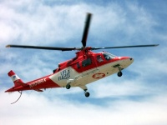chopper was not all bad if I could at least look out the windows and enjoy the views. The morphine had really kicked in and I was feeling pretty good. However, as a packaged trauma patient, movement of any kind was near impossible and highly discouraged and I was reminded several times of this by my caring flight crew. It was all I could do to look sideways enough to just see the Wasatch Mountains as we flew north toward the hospital. The landing and subsequent transport from the helipad into the waiting hands of Dr. White and his 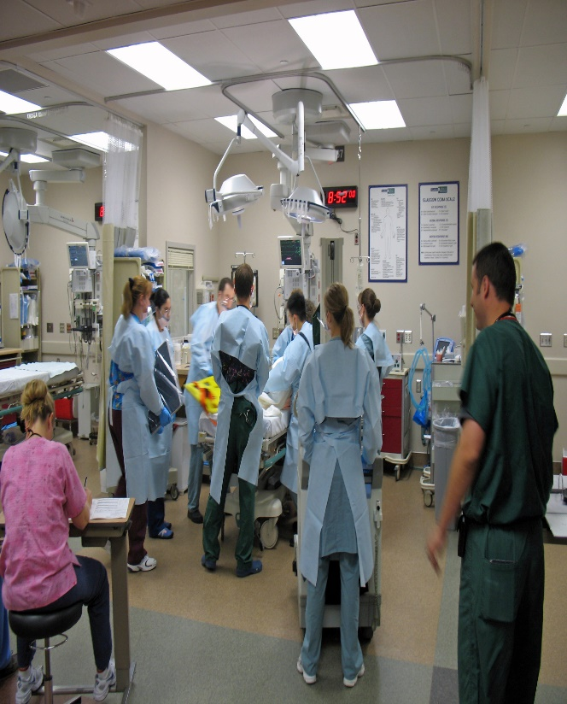 skilled ER team was brisk and before I knew it, the extent of my injuries had been discovered and I was being prepped for surgery.
My x-rays had revealed not only a series of right leg femur fractures, but also a lumbar spine compression fracture and other lower right leg fractures. Additionally, a massive hemorrhage in my upper thigh which was quickly draining my blood supply and had to be corrected immediately. It was later determined that at least three units of blood had been lost inside my leg before the surgeons were able to get it stopped and this pooled blood proved to be one of the biggest hindrances to my recovery in the coming months. Surgery lasted nearly seven hours but when I recovered, Dr. Butterfield and his surgical 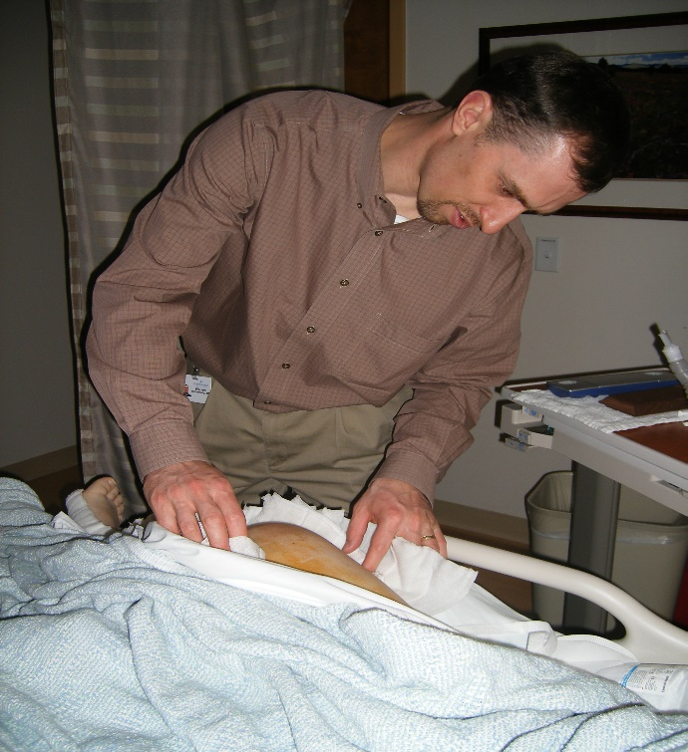 team had done an extraordinary job of reconstructing my leg and repairing my other injuries. Remarkably, due to the advanced surgical methods used with me, just two days after my injury and with some assistance, I was able to stand upright on my reconstructed leg and I never had a cast! Unfortunately, due to my blood loss, each time I would stand during those first few days, it would result in my fainting. However, within a couple of weeks I was able to stand with a walker and even walk short distances again. During the two months that we were waiting for the compression fracture in my spine to heal, I was required to wear a two-piece torso brace. This brace had the look and feel of a turtle shell and by design, restricted normal movement while keeping my spine in proper alignment. It was intensely uncomfortable and during that time, I could not sit up, tie my own shoes and so many other things that I had taken for granted before. To adapt, I 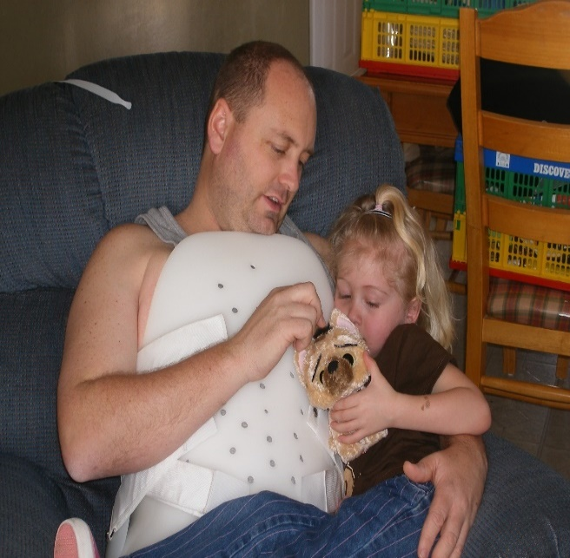learned to use all types of devices which allowed me to reach for things and to again be able to put on my own socks and shoes. I became proficient with both a wheelchair and a walker, eventually graduating to crutches and then to a cane. Finally, after 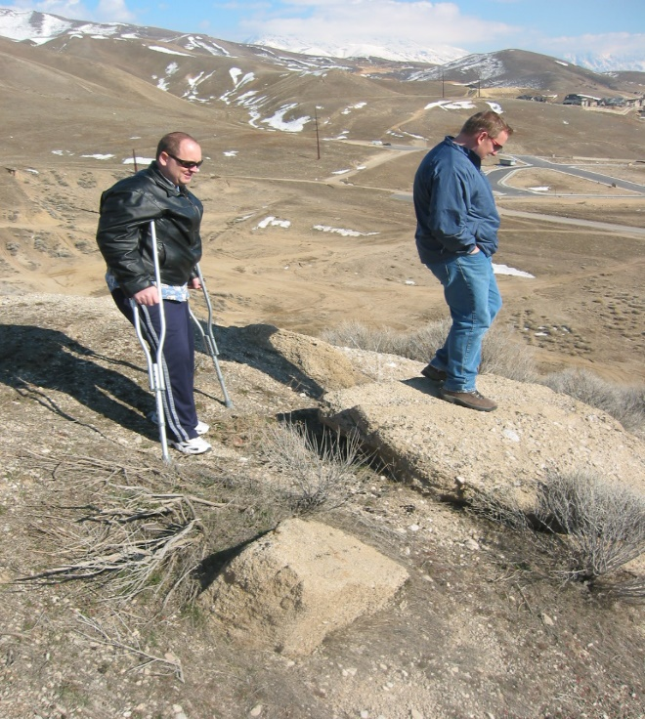more than nine months of intensive physical therapy, I was able to walk normally on my own again and it was fantastic!
I returned to the air in mid-October of 2008 and flew several more times after 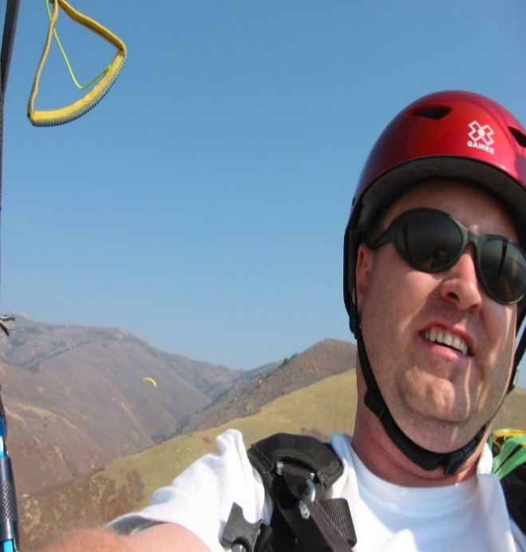that. It felt great to face my fears and to overcome the anxieties I had developed during my ordeal and I was so happy to be back in the air again! I thought to myself that I had finally come back and that I would now be able to continue pursuing my passion. This was short-lived however. In an effort to ease my wife’s fears, I was flying in secret which I could not do for long before it got the better of me. She never asked me to stop flying but it was hard for her and I was brutally conscious of this. She had been there at my side the entire time and it had been an intensely difficult thing for her as well. I was not willing to lose sight of that. As time wore on and life became busier in other ways, I found myself losing touch with my dream of flying. It has now been over three years since my last flight and this has been very difficult for me to deal with. Ironically, what was once such an exquisite celebration of life for me has now become somewhat of a source of personal
longing and regret.
Leonardo Da Vinci stated, “For once you have tasted flight, you will forever walk the earth with your eyes turned skyward, for there you have been and there you will always long to return.”
Today the limp is rarely seen and the scars have healed rather nicely but not a day goes by without at least a brief reflection upon my fantastic, albeit, too short, experience as a pilot. Of course, I am grateful to be alive and I will always relish that fact, however, I struggle to find a lasting satisfaction in these thoughts where flying is concerned. I tell myself that someday, like the ancient Phoenix, I too will rise again and return to the sky.
For there, I have been and there I will always long to return . . .
