Dave Nuttall
ENG 2010 7:00p
Position Paper
The Radical Approach
Our Earth is a vast place filled with many resources such as timber, oil, water and open spaces. There are also many people. With a current population of over seven billion residents and growing, some of earth’s resources are arguably becoming strained or even depleted to extinction. By their own interpretations of this issue, two groups have emerged, each believing that their ultimate responsibility is to save the planet.
Members of the environmental group, Earth First!, see themselves as 
warriors for Mother Earth in a battle to reclaim her, no matter the cost. While most people would typically characterize Earth First! members as radical environmentalists,
“Phasing out the human race will solve every problem on earth, social and
environmental.”
Dave Foreman –
Founder of Earth First!

primarily by virtue of their methods, they see themselves as a humane group which does not hurt other people in their efforts to meet their goals. Instead, their preferred tactic is sabotage, often referred to as “monkey wrenching” or “ecotage”. Various forms of civil disobedience are often employed. These include actions such as “tree sitting” which literally involves climbing high into a tree and refusing to come down for weeks and even years, in order to stop logging companies from cutting down an “old growth” tree. In many cases, activists have chained themselves onto heavy equipment so that it cannot be moved or operated.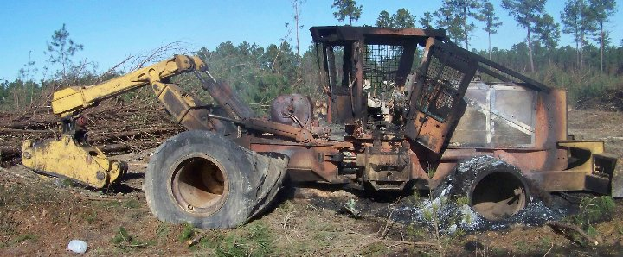
Monkey wrenching is typically a more drastic approach and usually involves seriously damaging or destroying pieces of heavy equipment. Offices and supplies used by developers and logging groups are often targeted as well . Hindering or discouraging these type of operations as well as stopping “suburban sprawl” or developing into wild areas have proven to be high on their task list. Taking action, no matter the cost, in order to stop these exploitations against Mother Earth is not only felt to be a justifiable action by most members of this group, but it is in fact cause for celebration when it occurs. Through the years, millions of dollars have been lost due to their monkey wrenching exploits.

The second group is known as the Wise Use Movement and they pride themselves in their anti-environmental approach to public land usage. This group is comprised of ranchers and private land owners who have personally experienced land rights conflicts as well as other encroachments and feel that they have been pushed too much by outside causes. Many of them watched in horror as their livelihoods were threatened by special projects sponsored by environmental groups and government agencies. One such project was the highly publicized and controversial reintroduction of wolf populations on public 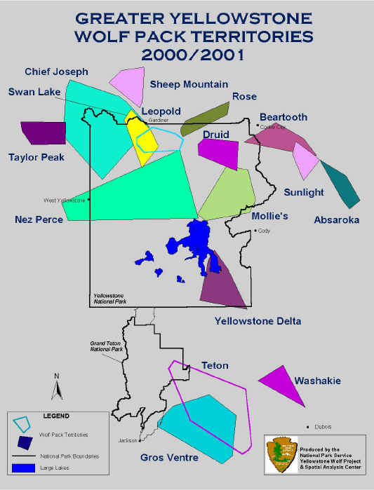
lands and national parks. As was the case with the wolf reintroductions inside Yellowstone National Park, selected areas often bordered private ranches putting livestock at risk and even jeopardizing the safety of many of the homeowners. Initially, the ranchers were not allowed to defend their lands and herds from these new wolf packs due to their being listed as an endangered species. Freshly released into the surrounding hills and valleys, the wolves knew nothing of property boundaries and were simply eager for the next easy kill. Lambs and calves were the perfect prey for the wolves and the 
ranchers could do nothing to stop the butchery. Feeling powerless, they were outraged as the wolves continued to attack their livestock. Out of desperation, they
began to rally together, looking for support in saving their way of life and their incomes. Their numbers began to grow as they found sympathy among unemployed loggers as well as recreational enthusiasts who were tired of seeing what they felt were unbridled public land closures. The Wise Use platform began to focus heavily on reducing the amount of protected lands. They believe that all lands should be made available to everyone, not only for recreation and public enjoyment but also for the conquest of natural resources such as oil and timber. Wise Use members strongly believe that government has been too heavy-handed in its administration of public lands including our national parks. As a result Wise Use efforts also became focused toward reducing government involvement in these matters, and pushing for the opening of previously closed lands and providing unrestricted public land access to all. In recent years, Wise Use efforts have generated more public attention as their lobbying for public land access gained even greater momentum. Motorcycle and ATV clubs around the country who were hoping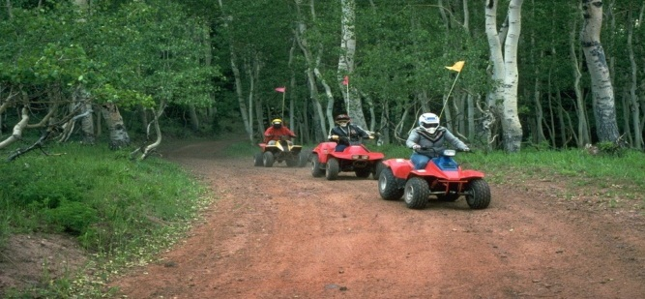
to keep trails and access points open for the future of their sport, continued to get involved. A principal tenet was their belief that the government and the environmental lobbyists shared a “lock ‘em up and keep ‘em out” philosophy in their approach to 
public lands. Rallies have been organized in an effort to foster additional support from private groups as well as public and political entities.
Extremist Activities Exposed
Similar to the extreme tactics employed by members of Earth First! in their own highly justified cause, Wise Use also has a darker side, one in which some members have also been involved in extremist activities. Considering the origin of the Wise Use movement, these activities which include arson, assaults and threats to property and life seem to be hypocritical. Open threats have been somewhat common at some Wise Use rallies including statements eluding to the possibility of blood running in the streets if government officials tried to stop their efforts. In other cases, National Park vehicles have been shot at and vandalized and Park Rangers have had their residences damaged and destroyed by pipe bombs and arson attacks (Helvarg). In 1998, a hotly contested plan to expand Vail Mountain Resort in Colorado, came to a head when resort contractors began developing into an area which environmental groups believed to be the “last, best Lynx habitat in the state.” In an effort to shut down the developments and to send a message to the world, the E.L.F. or 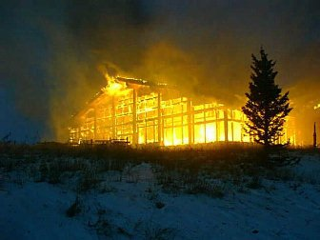Earth Liberation Front, an offshoot of Earth First!, set fire to several buildings within the resort including a massive new ski lodge which was nearing completion. Shortly afterward, the E.L.F. claimed responsibility for the fires by releasing an anonymous message in which they stated that “putting profits ahead of Colorado’s wildlife will not be tolerated.” The E.L.F. further explained their actions taken at Vail by stating that these steps were “just a warning” and that they would “be back if this greedy corporation continues to trespass into wild and unroaded areas.” With total loss estimates nearing the $12 Million mark, 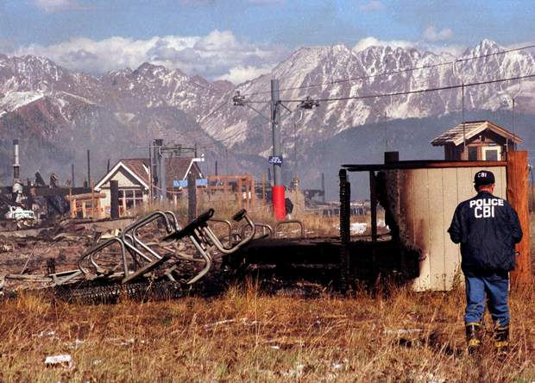
seven different fires were started that day, causing damage to many structures and even destroying chairlifts at the resort. Both the E.L.F. as well as another faction, the A.L.F. or Animal Liberation Front, which chiefly targets anyone whom they believe to be exploiting animals, have claimed responsibility for a wide variety of similar acts around the globe since the early 1990’s. The A.L.F. and the E.L.F. both share similar ties to the Earth First! group. (Paulson)
Even Closer to Home
Ten years after Vail, in a surprising new approach to the concept of monkey wrenching, University of Utah student, Tim DeChristopher stunned the natural resources world when he attended a federal oil and gas lease auction being held in Salt Lake City. 
DeChristopher, posing as a legitimate
bidder, won the exploratory rights to thousands of acres of public lands. When it was discovered that he was an imposter with no intent to pay for or develop the leases he had won, the damage had already been done. DeChristopher’s actions led to a lengthy court battle in which he was eventually found guilty. However, the immediate as well as long-term effects on the leases at auction that day were forever altered. By bidding on those parcels and then failing to pay for them, not only did he tie up many thousands of acres of land earmarked for exploration, but he also artificially drove up the prices on the remaining parcels causing the market values to be overly inflated (MacDonald).
In addition to the actions of Mr. DeChristopher, other events have occurred right here in the Salt Lake Valley which provide evidence that these activities are not just happening somewhere else. They are in fact, happening right here in our own back yard too. In March of 1997, the A.L.F. claimed responsibility for several explosions that destroyed five feed trucks and an office
at the Fur Breeders Co-op in Sandy, Utah. According to reports, the perpetrators used pipe bombs in the attack (Paulson).
Forest Warfare
Environmental activists sit up in trees marked for cutting, chain themselves to trees and even drive long metal spikes into their beloved trees. These spikes are intended to cause damage to chain saws when loggers attempt to cut them down as well as cause even greater damage if the spikes make it all the way to the mills. Tree spiking became a more common threat to the loggers. In an effort to avoid injuries, logging companies began using metal detectors to identify spike locations before cutting. Once this happened, some activists 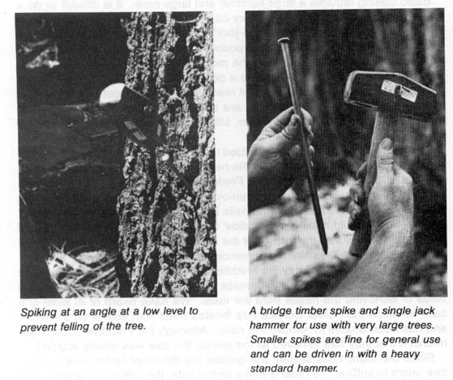then began using undetectable ceramic rods instead and loggers were again at risk. Earth First! and the E.L.F. both claimed that any injuries occurring as a result of the spikes were not their fault because they would warn the logging companies that spikes have been placed hoping that the companies would just skip those areas altogether. The continued hazard for loggers and mill workers often became life-threatening. According to Jonathan Carter, a spokesman for Earth First! in Maine, “there is no compromise on this issue, for us, it’s a matter of biological survival.” With this action, the message was now even more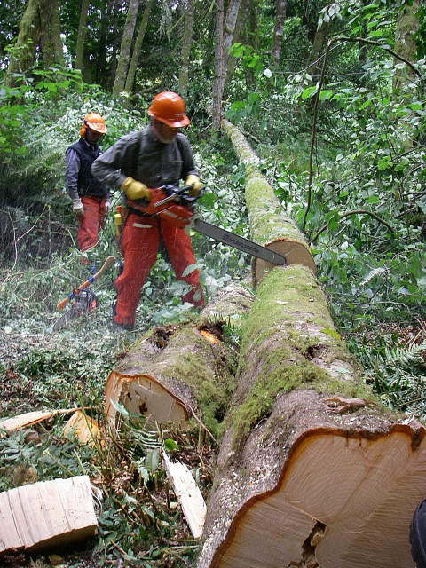
clear that protecting the environment had become more important to these radical groups than preserving human life and safety (Turkel).
Is Green the New Red?
When one considers the zeal of groups such as Earth First! and the E.L.F., it seems to almost have a religious quality, in which members may disregard anything else that does not fit within their belief system. 
British cabinet minister, Nigel Lawson stated that “with the collapse of socialism, those who dislike capitalism have been obliged to find a new creed.” He goes on to suggest that “environmentalists have turned climate change from being a political issue into a secular religion. Green is the new Red.” Additionally, certain ritualistic tenets exist among most environmentalists such as recycling, consuming only organic foods and denouncing all who believe or act differently from them (Sibley). When compared to the Wise Use Movement, a clear difference emerges. While it is true that Wise Use activists have also used tactics that have left people hurt and feeling threatened, their motivations 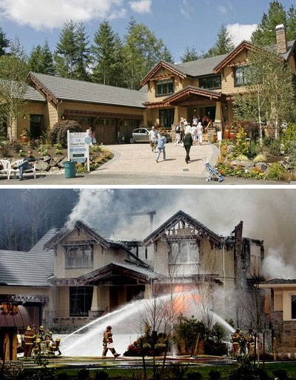
come from the need to protect things which they have worked hard for including their lands, livelihoods and families, the things that they care about. They are also driven by their passions for getting out and enjoying the land rather than keeping it 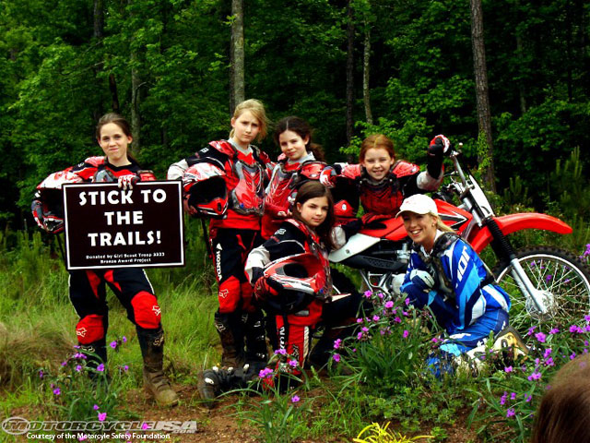
locked up forever in a way that it cannot be appreciated by anyone. Of course, one’s passion for a cause does not justify the levels of violence which seems to occur from both sides. Extremism can be very unhealthy no matter the cause. I also believe strongly that we have an obligation to manage our resources in a responsible manner and that we should be mindful of what we are handing down to future generations. That being said, as I conclude my
research, I feel that I have more in common with the Wise Use Movement than I do with Earth First! or the E.L.F. I do not condone the radical approaches of any of these groups but I do love forests and nature with the solitude and beauty they offer. Keeping trails open and being able to access these wild places on a backpacking trip is the ultimate excursion for me. I would much rather visit and experience these wondrous places for myself than to lose that right and have to visit them only in my faded memories. Every trip leaves me looking forward to my return.


Works Cited

Helvarg, David. "Open Hostilities." National Parks. Sept./Oct. 1996: 36-41. SIRS Issues Researcher. Web. 30 Jan 2013.
MacDonald, Christine. "The New Environmental Activists." E Magazine (Vol. 21, No. 3). May/Jun 2010: 22. SIRS Issues Researcher. Web. 30 Jan 2013.

Paulson, Steven K. "Eco-Terrorists Toughen Tactics." Philadelphia Inquirer (Philadelphia, PA). Oct. 23 1998: n.p. SIRS Issues Researcher. Web. 30 Jan 2013.
Sibley, Robert. "Cult of Environmentalism." Star-Phoenix Saskatoon, Saskatchewan, Canada. 09 Jan 2010: F.9. SIRS Issues Researcher. Web. 30 Jan 2013.
Turkel, Tux. "Ecological Saboteurs Threaten Foresters in Old Maine Forest." Maine Telegram (Portland, ME). Nov. 18 1990: A1+. SIRS Issues Researcher. Web. 30 Jan 2013.

